The periodic table: elements ordered by their subshells

Ben Alper

Cranfield University, Bedfordshire, MK43 0AL, ben_alper@live.com

Abstract: This article introduces a periodic table in which the elements are ordered by the energy level of their subshells and by the number of electrons in their outer subshell. This layout makes it easier to understand how the properties of all elements relate to the orbital structure of the atom. The table maintains periodicity, and gives the electron configurations required in modern chemistry but missing from the traditional table. The table also includes electron promotion, which is a simple concept for characterising the electron structure of elements that do not conform to the Aufbau principle.

Development of the periodic table

Dmitri Mendeleev created the forerunner of the traditional periodic table 140 years ago in 1869. The elements were ordered by atomic weight and arranged so that elements with similar repeating properties were aligned in columns. Unlike other tables, Mendeleev’s was able to predict the weight and properties of new elements [1].
In 1919 Henry Moseley reordered some elements in order of atomic charge rather than atomic weight: swapping argon with potassium, and putting cobalt before nickel [1].
In 1945 during the Manhattan project, as Glenn Seaborg synthesised new elements he noticed that the actinide group had different properties to the transition metals [2]. He removed it and put it in a separate block along with the lanthanide group resulting in the modern version of the traditional periodic table.

Quantum theory of electron subshells

In 1923 Bohr proposed that the periodicity of the periodic table could be explained if the electrons (or quanta) orbiting the nucleus were ordered in shells. This was corrected to include subshells by Stoner & Sommerfeld in 1924, and was further corrected by Pauli 1925, Schrodinger in 1926 and finally Madelung in1936 [3].
Despite the advances in understanding of atomic structure, the periodic table was left unchanged, perhaps because no one could be sure that the most recent change to the subshell structure would be the last. Even now, there is uncertainty over whether experimental evidence really proves the order of the subshells. However there have been no major changes to the consensus on subshell structure in the last 70 years making sudden new developments less likely.

The order of electron subshells

There are 4 types of subshell known as s, p, d and f. S subshells contain up to 2 electrons; p subshells contain up to 6 electrons; d subshells contain up to 10 electrons and f subshells contain up to 14 electrons. Prefixing each subshell type is the number of the shell known as the ‘principle quantum number’ thus the full name of a subshell is written as e.g., ‘1s’.
The naming convention of the principle quantum number is an artefact of the outdated Bohr model of the atom and can be misleading since the higher subshells in a Bohr shell overlap the lower subshells of the next shell, as shown in Figure 1. Since successive electrons are added in the energetically lowest available level, the order in which the subshells are filled does not always follow the order suggested by the notation (Table 1).

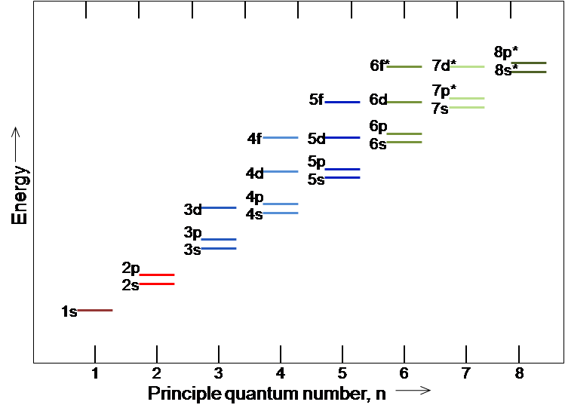
Figure 1: Energy levels of the subshells.

With a small number of exceptions, the electron subshells of each element are filled in the same way as for the element before it, but with an extra electron in the outermost subshell. This is known as the Aufbau principle. When a subshell is filled, then the next outermost subshell begins to be filled, as shown in Figure 2.

Table 1. The order in which the subshells are filled for the first 36 elements [4].
Element Symbol No Electron Configuration
Hydrogen | H | 1 | 1s¹
Helium | He | 1 | 1s²
Lithium | Li | 3 | 1s² 2s¹
Beryllium | Be | 4 | 1s² 2s²
Boron | B | 5 | 1s² 2s² 2p¹
Carbon | C | 6 | 1s² 2s² 2p²
Nitrogen | N | 7 | 1s² 2s² 2p³
Oxygen | O | 8 | 1s² 2s² 2p⁴
Fluorine | F | 9 | 1s² 2s² 2p⁵
Neon | Ne | 10 | 1s² 2s² 2p⁶
Sodium | Na | 11 | 1s² 2s² 2p⁶ 3s¹
Magnesium | Mg | 12 | 1s² 2s² 2p⁶ 3s²
Aluminium | Al | 13 | 1s² 2s² 2p⁶ 3s² 3p¹
Silicon | Si | 14 | 1s² 2s² 2p⁶ 3s² 3p²
Phosphorus | P | 15 | 1s² 2s² 2p⁶ 3s² 3p³
Sulfur | S | 16 | 1s² 2s² 2p⁶ 3s² 3p⁴
Chlorine | Cl | 17 | 1s² 2s² 2p⁶ 3s² 3p⁵
Argon | Ar | 18 | 1s² 2s² 2p⁶ 3s² 3p⁶
Potassium | K | 19 | 1s² 2s² 2p⁶ 3s² 3p⁶ 4s¹
Calcium | Ca | 20 | 1s² 2s² 2p⁶ 3s² 3p⁶ 4s²
Scandium | Sc | 21 | 1s² 2s² 2p⁶ 3s² 3p⁶ 3d¹ 4s²
Titanium | Ta | 22 | 1s² 2s² 2p⁶ 3s² 3p⁶ 3d² 4s²
Vanadium | V | 23 | 1s² 2s² 2p⁶ 3s² 3p⁶ 3d³ 4s²
Chromium | Cr | 24 | 1s² 2s² 2p⁶ 3s² 3p⁶ 3d⁵ 4s¹
Manganese | Mn | 25 | 1s² 2s² 2p⁶ 3s² 3p⁶ 3d⁵ 4s²
Iron | Fe | 26 | 1s² 2s² 2p⁶ 3s² 3p⁶ 3d⁶ 4s²
Cobalt | Co | 27 | 1s² 2s² 2p⁶ 3s² 3p⁶ 3d⁷ 4s²
Nickel | Ni | 28 | 1s² 2s² 2p⁶ 3s² 3p⁶ 3d⁸ 4s²
Copper | Cu | 29 | 1s² 2s² 2p⁶ 3s² 3p⁶ 3d¹⁰ 4s¹
Zinc | Zn | 30 | 1s² 2s² 2p⁶ 3s² 3p⁶ 3d¹⁰ 4s²
Gallium | Ga | 31 | 1s² 2s² 2p⁶ 3s² 3p⁶ 3d¹⁰ 4s² 4p¹
Germanium | Ge | 32 | 1s² 2s² 2p⁶ 3s² 3p⁶ 3d¹⁰ 4s² 4p²
Arsenic | As | 33 | 1s² 2s² 2p⁶ 3s² 3p⁶ 3d¹⁰ 4s² 4p³
Selenium | Se | 34 | 1s² 2s² 2p⁶ 3s² 3p⁶ 3d¹⁰ 4s² 4p⁴
Bromine | Br | 35 | 1s² 2s² 2p⁶ 3s² 3p⁶ 3d¹⁰ 4s² 4p⁵
Krypton | Kr | 36 | 1s² 2s² 2p⁶ 3s² 3p⁶ 3d¹⁰ 4s² 4p⁶

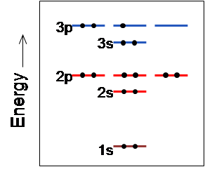
Figure 2: Filled electrons states for a phosphorus atom

The order in which the subshells are filled goes in order of the energy level of the subshell, rather than the shell number. For example the 4s electron subshell is filled before the 3d subshell. The order of subshell energy levels can be seen in Figure 1. D subshells have similar energy levels to the f subshell of the shell below and there is in fact some overlapping of the 5f and 6d subshells. The number of elements with electron positions filled in an unexpected order is 19 out of 120 elements. However, in general the electrons positions are filled as expected, and the order in which the subshells are filled are as follows: 1s, 2s, 2p, 3s, 3p, 4s, 3d, 4p, 5s, 4d, 5p, 6s, 5f, 5d, 6p, 7s, 5f, 6d, 7p, 8s.
From table 1, it can be seen that elements such as chromium and copper do not follow the usual pattern of the Aufbau principle. Their unusual configuration is highlighted in bold in table 1. The change in order of the electrons can be described by ‘electron promotion’ by which an element in a lower subshell transfers to higher subshell as the lowest energy state for that element.

Elements ordered by their outer subshell

In the table ordered by subshells, shown in Figure 3, along the x axis, the elements are ordered by the energy levels of their outer subshell. The number of electrons in the outer subshell of each element are found down the y axis. The number of electrons in the outer subshell affects the properties of the elements and accounts for the periodicity found in the periodic table.

Advantages of the table ordered by subshells

The table ordered by subshells is simpler and more orderly than the traditional periodic table and other designs. This gives advantages to students studying chemistry as it allows them to understand how the position and properties of an element relate to its atomic structure. The user can visualise the table as an atom with layers of subshells.
In terms of visual cohesiveness, the table’s continuous progression includes the lanthanide and actinide groups. The table has the same width as the traditional table: 18 elements; and similar depth: 14 elements compared with 9 elements and a gap.
The layout provides improvements as a teaching aid to find the formulae of compounds, to find atomic number, mass and valence of an element, to identify properties of groups of elements, and to look up electron configuration.
One can see directly by looking at the table, how many electrons are in the outer subshell of each element and how many it needs to gain or loose to become stable. There is a tendency for elements to have valences that result in them gaining or loosing electrons to have either a full p outer subshell, a full d outer subshell, a d subshell with 8 atoms, an f subshell with 12 atoms or a full s subshell. These five favourable configurations account for 60% of all valences and the next five most favourable configurations account for 77% of all valences.

Figure 3: The table ordering elements by the energy levels of their subshells.

In the case of covalent bonding, in a reaction between oxygen and hydrogen for example it can be seen that hydrogen needs to gain or loose one electron and that Oxygen needs to gain two electrons. This would imply two hydrogen atoms sharing their outer electrons with a single oxygen atom, giving a full 1s subshell for hydrogen and a full 2p subshell for oxygen. In the case of ionic bonding, germanium gives its two 4p electrons to two chlorine atoms resulting in germanium having a full outer 3p subshell. Germanium can also give up its two outer d subshell electrons to a further two chlorine atoms resulting in 8 electrons in its outer d subshell, which is also one of the five most favourable configurations. The table makes it simpler to see how the multiple valences of each element affect the changes in electron state and allows a wider range of valence bonding predictions than the traditional periodic table.
The table also eases the introduction of students to quantum effects, understanding of which is essential to modern chemistry. Computational chemists now use electron configuration to predict atomic stability, boiling point, conductivity and reactivity between elements. Valence bond theory does not give an accurate description of molecular-level properties of bonds between more than two atoms. The full electron configuration of the atoms must be considered and bonds described by the molecular orbit of the electrons using molecular orbit theory. These models are becoming standard methods used in chemistry software packages. Electron configuration is also used in crystal field theory to explain magnetic properties and colours of elements, and in ligand field theory for explaining σ and π bonding in molecules [5].
As such a growing number of users in fields such as chemistry, physics, biology and materials science regularly need to look up and understand electron configuration. The traditional periodic table is not suitable for the representation of this information due to the lack of ordering of the subshells.

Use in identifying electron promotion

Elements such as copper, silver, gold and others have unusual arrangements of electrons, which can be explained by relativistic effects [6]. For example silver has 10 electrons in its outer subshell rather than 9. All of the unusual configurations can be explained by electron promotion, in which an electron that would normally be in a lower subshell is found instead in the outer subshell. The periodic table ordered by subshells shown at the end of this article (Figure 5) identifies elements with electron promotion and shows the types of electron promotion so that the user is aware of the atomic structure of the elements.

Types of electron promotion

There are two broad categories of electron promotion: in the first category an electron can jump from a lower subshell into the outer subshell of the element. In the second category an electron can jump from the outer subshell of the element into a higher subshell.
Examining ‘electron promotion’ in greater detail, one can see that there are four different types of electron promotion: an electron promoted from an s subshell; two electrons can be promoted from an s subshell; an electron can be promoted from an s sub shell that jumps over an f subshell into the outer d subshell; and an electron can be promoted from an f subshell. Examples (N is the number of electrons in the outer subshell):
Promoted s: an electron from the highest s subshell jumps up to the outer subshell: Cr, Cu have [Ar] 4s1 3d(N+1) and Nb, Mo, Ru, Rh and Ag have [Kr] 5s1 4d(N+1).

Double promoted s: 2 electrons from the highest s subshell jump up to the outer subshell: Pd has [Kr] 5s0 4d(N+2).

Jumping promoted s: an electron from the highest s subshell jump up to the outer subshell and jumps over an 'f' subshell to get there: Pt and Au have [Xe] 6s1 4f14 5d(N+1) and Uun and Uub have [Rn] 7s1 5f14 6d(N+1)

Promoted f: electron from outer f subshell jumps up to outer subshell: Gd has [Ba] 4f(N-1) 5d1 and Ac, Th, Pa, U, Np and Cm have [Ra] 5f(N-1) 6d.

Use of the table

Any predictions that can be made about the properties of elements by their position on the traditional table can be made with the table ordered by subshells.
Periodicity with regards to atomic radii, ionisation energy, electron affinity, metallic character, electronegativity and atomic emissions all hold true. For example noble gasses all have full p type outer subshells. Magnetic materials are all have a 3d outer subshell; highly reactive chemicals such as lithium, sodium, potassium and caesium all have s outer subshells with 1 electron, that is, they are in the same row. Calcium, strontium and barium all have s outer subshells with 2 electrons; sulphur, selenium and tellurium all have p outer subshells with 4 electrons; chlorine, bromine and iodine all have p outer subshells with 5 electrons; copper, silver and gold all have d outer subshells with 9 electrons. The noble metals all have d outer subshells with between 6 and 9 electrons in the outer subshell. Catalysts with similar properties such as nickel, palladium and platinum also all have d outer subshells but with 8 electrons.
For elements with p outer subshells, the properties change for larger atoms. For example semiconductors all have p outer subshells but the number of electrons in the outer subshell is higher for higher level p subshells. The relative conductivity gradually increases with larger atoms, even with the same number of electrons in the p outer subshell.
In general, to find an element with a similar property to another one, it is best to examine elements with an outer subshell of the same type and a similar number of electrons in the outer subshell.

Problems with the traditional table

The extreme left hand column of Figure 4 indicates the subshells that are filled as the atomic number increases. More than one electron subshell is represented in each row. By merging the subshells together the traditional periodic table reduces the clarity of the data it presents. In addition the 4f and 5f subshells are split across two different rows, as are the 5d and 6d subshells, adding further unnecessary complexity.

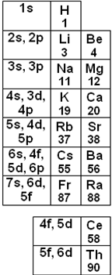
Figure 4: Subshells in each row of the traditional periodic table.

Other versions of the periodic table that include subshells

Hundreds of other types of periodic table have been published or have reached the popular media, however these are all variations on a small number of themes. Most relevant to this article is the “left step periodic table”, the first version of which was first published by Janet in 1928 [7]. Modern versions of the left step table succeed in grouping elements by their subshell and incorporating the lanthanide and actinide groups. This allows them to maintain much of the periodicity of the traditional table so that elements with similar properties are in similar positions.
However, the left step table has numerous shortcomings. While a knowledgeable user can use the left step table to find the number of electrons in the outer subshell of each element, this is no easier than with the traditional table. While the elements are grouped into blocks of subshells, they are not ordered by the energy level of their subshells nor does their ordering take into account electron promotion. As with the traditional periodic table this means that the table does not relate to the orbital structure of the atom and is not useful for finding electron configurations. While the shape of the left step table is simpler and more elegant than the traditional periodic table, it is very long and thin, which means, practically speaking, there is not enough space to include crucial information such as full element names, masses and atomic numbers. In terms of ease of use, the elements in the left step table are ordered from left to right. Since the atomic numbers are not in order it is difficult to follow.
There are many tables designed as spirals and circles to mimic the shape of atoms [7]. These tables succeed in linking the periodic table to the orbital structure of the atom. However spiral and circular tables make understanding periodicity almost impenetrably complex. The lack of straight rows and columns makes it difficult to follow the order of the elements or to identify valence.
In order to create spiral or circular tables it is necessary to sacrifice either the order of the elements or the order of the subshells. As such these tables are not ordered by the energy level of their subshells and so cannot be used for identifying electron configuration or electron promotion.

Conclusion

The periodic table ordered by subshells looses none of the utility of the traditional table, while adding clarity and compatability with electron configurations. For this reason it can be considered as a suitable candidate to replace the traditional periodic table as a common standard for all applications.

Acknowledgements

The author would like to acknowledge helpful discussions with Rajeeve Dattani and encouragement from Professor Jeremy Ramsden.

References

- Gorin, G. Mendeleev and Moseley: the principle discoverers of the periodic law. J. Chem. Educ. 73 (1996) 490-493.
- Seaborg, G.T. Prospects for further considerable extension of the periodic table. J. Chem. Educ. 46 (1969) 626-634.
- Scerri, E.R. The electronic configuration model, quantum mechanics and reduction. Br. J. Phil. Sci. 42 (1991) 309-325.
- Callister, W.D. Materials Science and Engineering: An Introduction, 7th edn. New York: Wiley (2007).
- Griffith, J.S. and Orgel, L.E. Ligand-field theory. Q. Rev. Chem. Soc. 11 (1957) 381-393.
- Pyykkö, P. Relativistic effects in Chemistry. Chem. Rev. 88 (1988) 563-594.
- Scerri, E.R. The Periodic Table, Its Story and Its Significance. New York: Oxford University Press (2007).

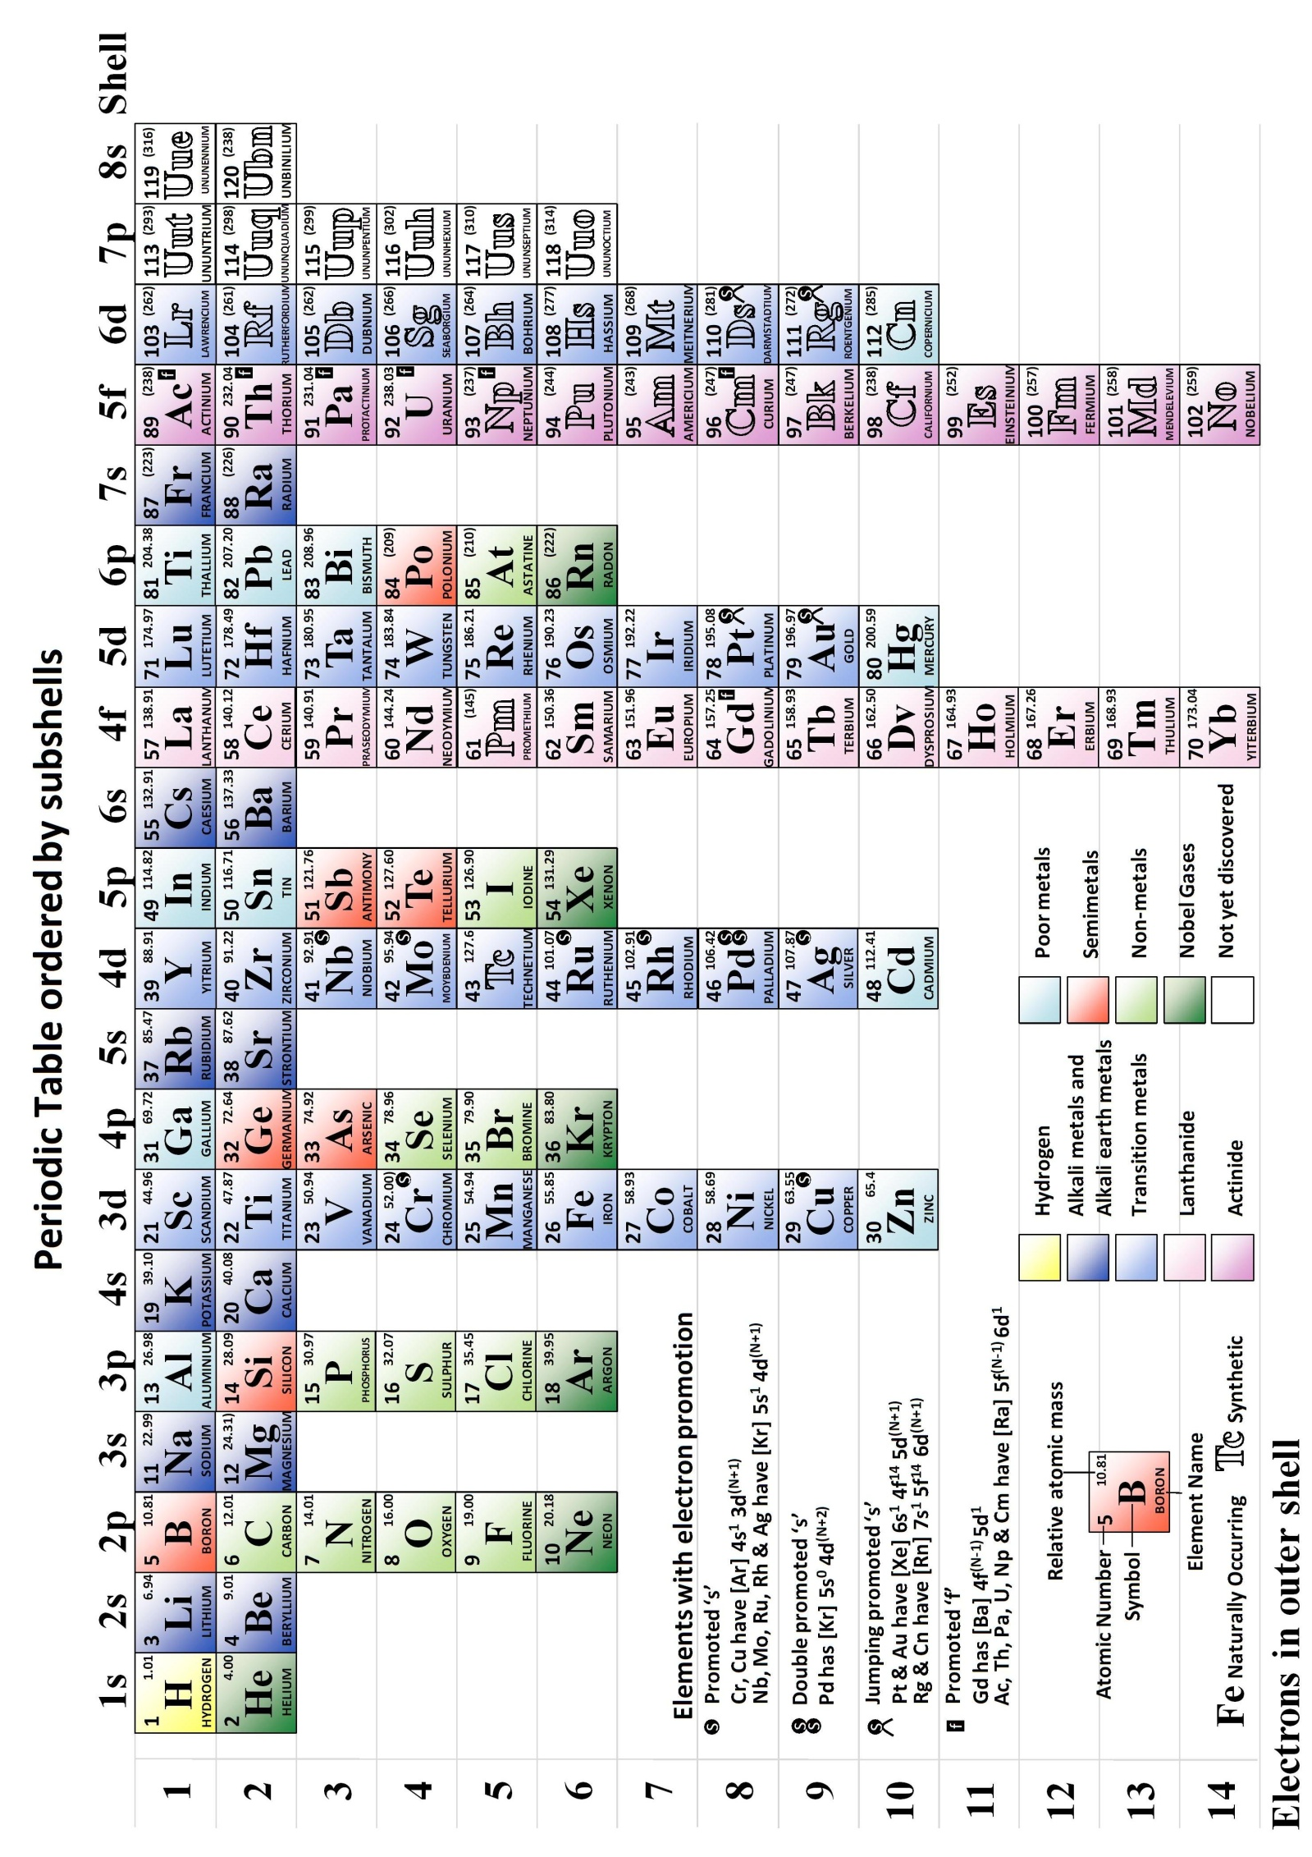

Figure 5: Periodic Table ordered by subshells, colour version

